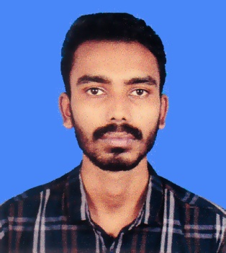CURRICULUM VITAE

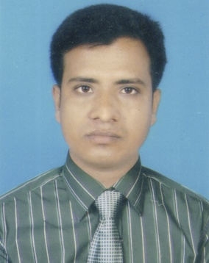OF

MD. MASUD SIKDER

House No: 14/A, Borobag,

Mirpur-2, Dhaka-1216

Mobile: 01627-649431

CAREER OBJECTIVE

Looking for hard and challenging job where I will have the scope to utilize my potentiality, creativity, adaptability and skill to do something innovative and from where I will be able to enhance my knowledge.

ACADEMIC QUALIFICATIONS

* **Higher Secondary Certificate (H.S.C)**
* Board : Dhaka
* Name of Institute : Sristy College of Tangail
* Group : Science
* Passing Year : 2020
* Result : GPA 4.33 (Out of 5.00)
* **Secondary School Certificate (S.S.C)**
* Board : Dhaka
* Name of Institute : Dhalapara S.U.P High School
* Group : Science
* Result : GPA 4.11 (Out of 5.00)
* Year of Passing : 2018

LANGUISTIC SKILL

* Bengali (Mother Language).
* English (Speaking, Listening, Writing, and Reading ability).

COMPUTER SKILLS

* Computer Office Application
* Computer Database Programming
* Internet browsing, Exal PowerPoint Etc.

WHY ME

* Confident enough to carry out duties with minimum instruction.
* Have skill in motivation and counselling and self-driven and change oriented.
* Able to work under challenging environment.
* Sincere and eager to learn & Good managerial skill
* Willing to work in team & Ability to motivate people
* Familiarity with information & communication technologies.

PERSONAL PROFILE

* Name : Md. Masud Sikder
* Father’s Name : Md. Obaidur Rahman
* Mother’s Name : Marium
* Date of Birth : 05-07-2002
* Height : 5.8"
* Blood group : AB+
* Sex : Male
* Marital Status : Unmarried
* Nationality : Bangladeshi (By birth)
* Religion : Islam
* Permanent Address : Vill: Chambaltala, P/O: Dhalapara

P/S: Ghatail, Dist: Tangail,

Declaration

I do hereby declare that the above information is true and correct to the best of my knowledge.

**Signature:**

Md. Masud Sikder

Date: